BUS 583 | Build 3 | Jaidin Haynes

Should we invest more in Office Supplies?
This was analyzed using a Claude analysis agent looking at 500 records from the Superstore sales dataset. It looked like Office Supplies would be the best category to focus on, but in the end I decided against that.

What the numbers showed
Office Supplies had the highest reported sales of $466,046 and profit of $146,403. This category had the highest profit margin of 31.4% followed by Furniture and Technology. Based on this chart, Office Supplies would be the best category to focus on first.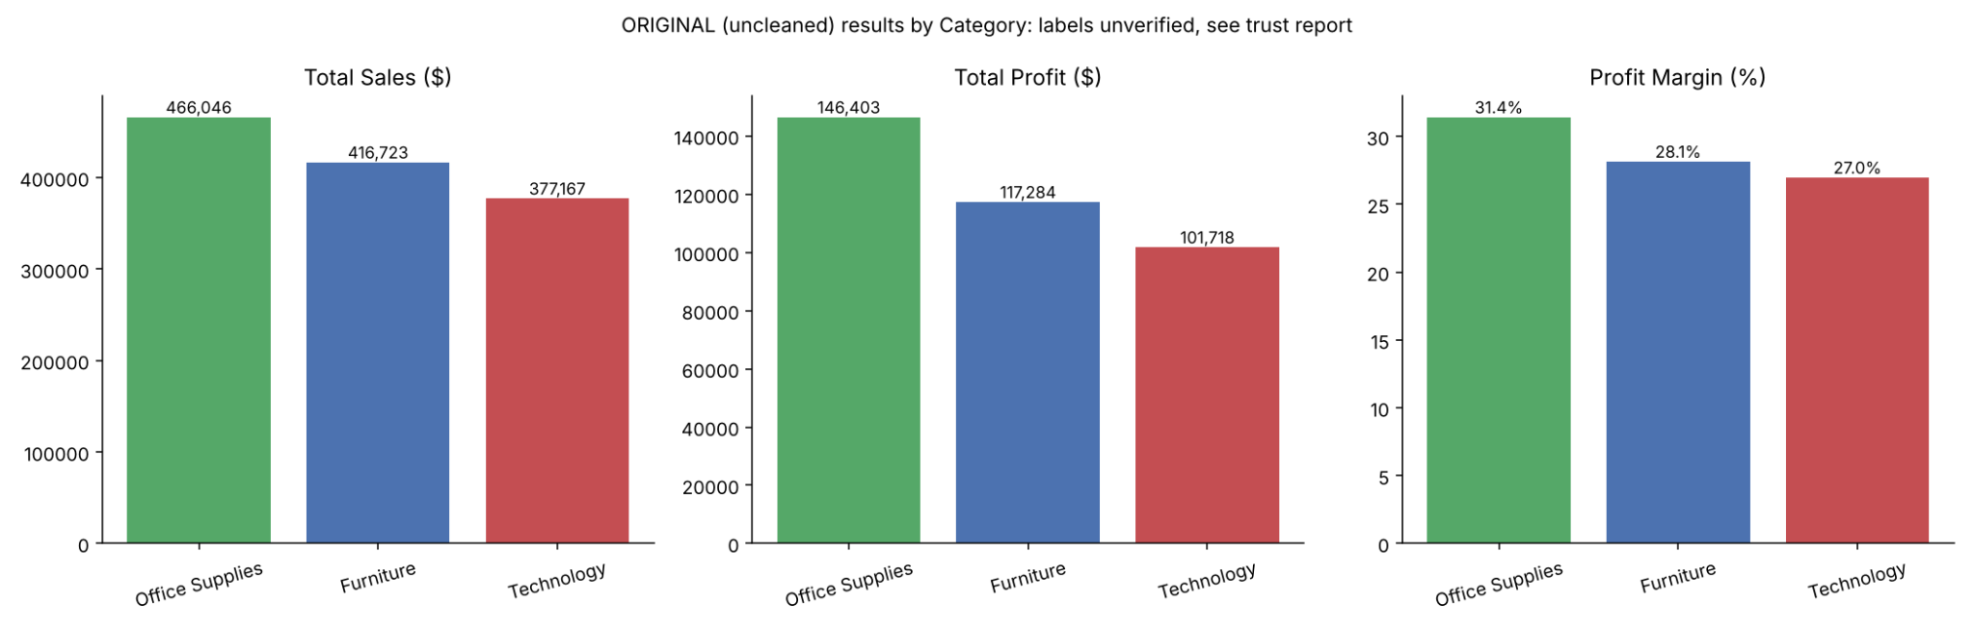

What made me question it
As mentioned above, many products’ labels were out of order.
For example, Phones were listed under Furniture, and Bookcases under Technology. Reorganizing the products into a standard subcategory (as opposed to the original Category column) revealed that the biggest profit came from Technology, not Office Supplies. This reorganization was merely an assumption on my part.
There were 65 such records in total, representing some 25% of the total reported profit in the file. Claude removed these from the comparison as a test, and the resulting margin for Office Supplies was approximately 23.9% (vs. 31.4% as reported).
While this does not prove that all 65 records were in error, it does make the original margin number suspect.

My decision
This would mean that I would not spend any money on additional stock, shelf space or advertising in any of the categories, until I had seen the correct product-category list and understood how the profit was calculated. I would then rerun the comparison to see if the data pointed to the same category.

One more thing I tested
In addition to testing the above, I tested out two restaurant review files, both of which contained a synthetic file of reviews with 5 basic messages (e.g. food was great, service was poor, etc.) across 1 to 5 stars. I found that while Claude was confident in some of his findings (e.g. that reviews were published within a certain time frame and that there were city-specific patterns in reviews), some of his claims were rather weak and he was able to retract them upon further challenge. This was particularly useful to note.

What made me question it
As mentioned above, many products’ labels were out of order.

For example, Phones were listed under Furniture, and Bookcases under Technology. Reorganizing the products into a standard subcategory (as opposed to the original Category column) revealed that the biggest profit came from Technology, not Office Supplies. This reorganization was merely an assumption on my part.
There were 65 such records in total, representing some 25% of the total reported profit in the file. Claude removed these from the comparison as a test, and the resulting margin for Office Supplies was approximately 23.9% (vs. 31.4% as reported).

While this does not prove that all 65 records were in error, it does make the original margin number suspect.
My decision
This would mean that I would not spend any money on additional stock, shelf space or advertising in any of the categories, until I had seen the correct product-category list and understood how the profit was calculated. I would then rerun the comparison to see if the data pointed to the same category.
One more thing I tested
In addition to testing the above, I tested out two restaurant review files, both of which contained a synthetic file of reviews with 5 basic messages (e.g. food was great, service was poor, etc.) across 1 to 5 stars. I found that while Claude was confident in some of his findings (e.g. that reviews were published within a certain time frame and that there were city-specific patterns in reviews), some of his claims were rather weak and he was able to retract them upon further challenge. This was particularly useful to note.

